**CropSense AI**

**Revolutionizing Small-Scale Farming with Data-Driven Solutions**

**Team Members:**

* Prasad Ayithireddi
* Sinchana V
* Abhishek Sriram
* Arun Nirmal
* Amey Joshi

**Executive Summary**

Agriculture is the backbone of India's economy, with small-scale farmers making up nearly 86% of the farming community. Despite being crucial to food production, these farmers face overwhelming challenges in managing their crops. Erratic weather, pest infestations, and resource inefficiencies have led to frequent crop failures and financial instability, making farming an unpredictable livelihood. This is where **CropSense AI** comes in.

CropSense AI is an intelligent, data-driven crop management system designed to empower small farmers with real-time insights and recommendations. By using advanced AI models, the system predicts crop yields, suggests optimal planting times, and alerts farmers to potential pest threats. It brings cutting-edge technology to the fields, helping farmers make informed decisions that increase productivity, reduce resource wastage, and ensure sustainable farming.

With **CropSense AI**, we aim to bridge the gap between traditional farming practices and modern AI-driven solutions, offering farmers a tool to not only survive but thrive. The system is designed to be affordable, intuitive, and accessible even in areas with limited internet connectivity. It holds the potential to transform small-scale farming across India, providing a lifeline to millions of farmers facing economic uncertainty.

**Introduction**

**Imagine being a small-scale farmer in rural India.** Your livelihood depends on a tiny plot of land, but every year, you face unpredictable monsoon rains, pest infestations, and rising input costs. You try your best, relying on age-old farming practices passed down through generations. Yet, despite your hard work, you're always at the mercy of nature. You plant your crops hoping for good yields, but the uncertainty of weather and lack of modern tools make it a risky gamble.

This is the reality for millions of farmers in India. **Small-scale farmers**, who cultivate less than 2 hectares of land, form the backbone of Indian agriculture. Yet, they face disproportionate challenges in an increasingly volatile environment. As climate change alters weather patterns and pests become more resistant, the need for smart, efficient farming tools is more urgent than ever.

Enter **CropSense AI** — a solution that harnesses the power of artificial intelligence to address the core problems faced by Indian farmers. This intelligent system offers a suite of features, from predictive yield analysis to pest alerts, that helps farmers make real-time, data-driven decisions. Our goal is simple: to give farmers the power to make informed choices that lead to higher yields, reduced costs, and sustainable farming.

At its core, **CropSense AI** is more than just a tool. It’s a lifeline for farmers looking to break free from the cycle of unpredictability and move toward a future where technology supports their daily decisions. Whether it’s determining the best time to plant, predicting how much water to use, or alerting them to potential pest threats, **CropSense AI** delivers actionable insights that can be the difference between success and failure.

**Problem Small Farmers Face and the Importance of CropSense AI**

For small farmers in India, the challenges seem endless. Most of them rely on unpredictable monsoon rains, which are becoming more erratic each year due to climate change. Without precise weather forecasting and tools for crop management, many farmers end up planting their crops too early or too late, resulting in poor yields and financial losses.

Here are some of the key problems small farmers face:

* **Unpredictable Monsoons**: Agriculture in India is heavily dependent on seasonal rains. However, climate change has caused these monsoons to become less reliable, making it harder for farmers to determine the right time for sowing and harvesting.
* **Pest and Disease Outbreaks**: Lacking access to advanced pest management tools, farmers lose significant portions of their crops each year to pests like locusts, bollworms, and fungal diseases. Without timely interventions, these outbreaks can devastate entire fields.
* **Limited Access to Technology**: Many small farmers, particularly in rural areas, do not have access to modern farming tools, weather forecasts, or real-time data. As a result, they struggle to make informed decisions about planting, watering, and harvesting their crops.
* **Resource Inefficiency**: Without precise data on soil health and water availability, farmers often overuse fertilizers and irrigation water, driving up costs and contributing to environmental degradation.

**CropSense AI** addresses all of these challenges head-on. By providing farmers with data-driven insights, the system helps them:

* **Accurately Predict Crop Yields**: Farmers can make better decisions about when to harvest and how much to expect, allowing for more effective sales and resource management.
* **Optimize Planting Schedules**: With localized soil and weather data, CropSense AI recommends the best times to plant, taking the guesswork out of farming.
* **Receive Timely Pest and Disease Alerts**: Based on environmental data, the system alerts farmers to conditions that are conducive to pests and diseases, helping them take preventive action before significant damage occurs.
* **Improve Resource Efficiency**: By providing precise recommendations on water and fertilizer use, CropSense AI helps farmers reduce input costs while ensuring their crops receive the nutrients they need.

With these capabilities, **CropSense AI** has the potential to transform small-scale farming in India, helping farmers not just survive but thrive.

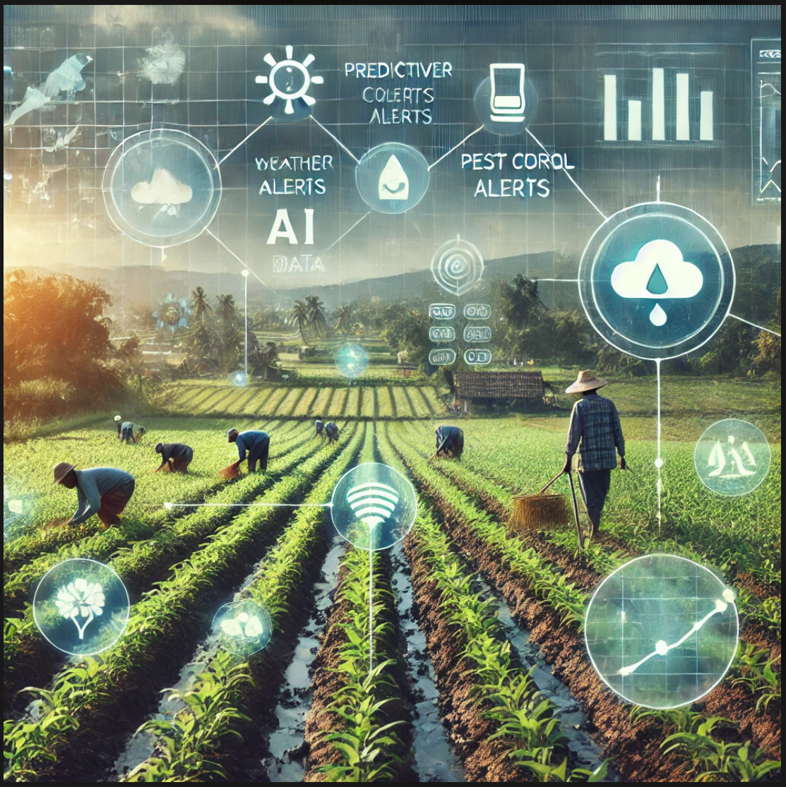

**2) Prototype Development Report:**

**Crop Yield Prediction and Pest/Disease Alerts**

**GitHub Repo Link:** [**Project Link**](https://github.com/abhishek-sriram/Feynn-Labs-Internship-2024/blob/main/Task%20-%20AI%20Product%20Service%20Prototype%20Development%2C%20Business%20and%20Financial%20Modelling/Crop_Yield.ipynb)

**1. Steps Involved in Prototype Development.**

**1.1 Data Collection**

Data was collected from various sources like Kaggle, containing information on weather conditions, soil properties, and crop yields across different regions. The data was cleaned, preprocessed, and split into training and testing sets using Python libraries like Pandas, NumPy, and Scikit-learn.

Loading the dataset:

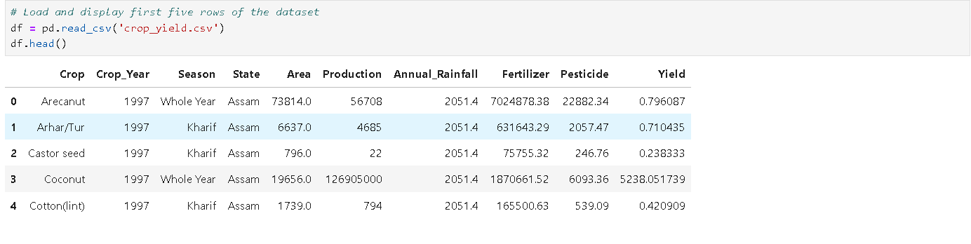

**1.2 Exploratory Data Analysis**

Exploratory Data Analysis (EDA) involves examining datasets to summarize their main characteristics and discover patterns, trends, and relationships between variables. In this project, EDA was conducted to understand the distribution of key features such as temperature, humidity, soil moisture, and rainfall, and how they relate to crop yield and pest occurrence.

Performing EDA: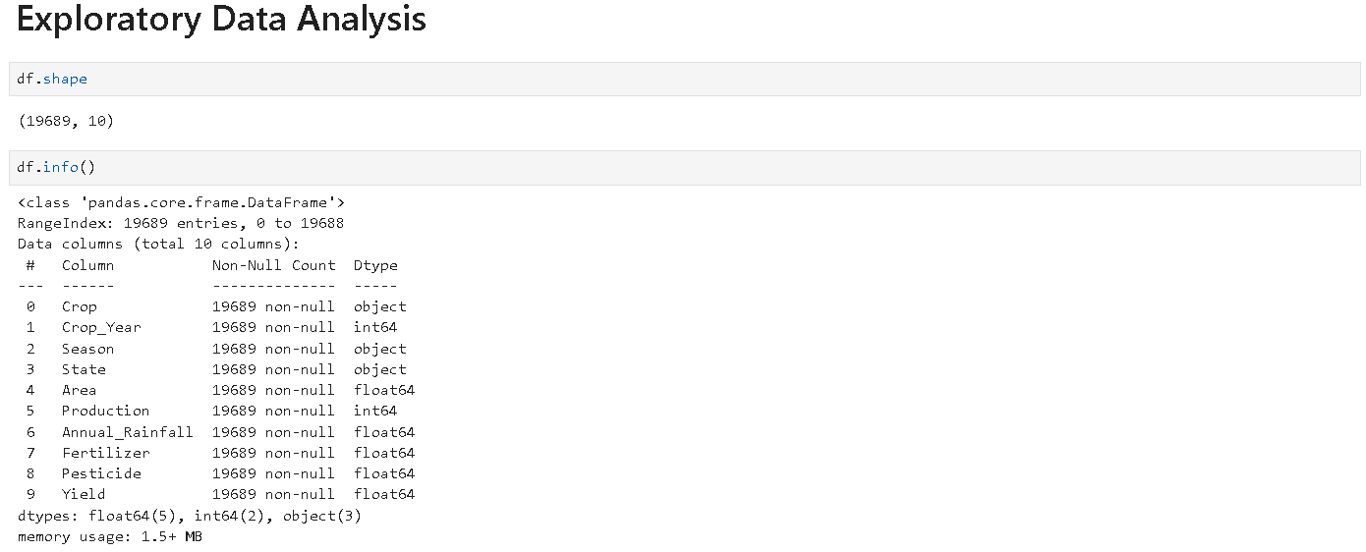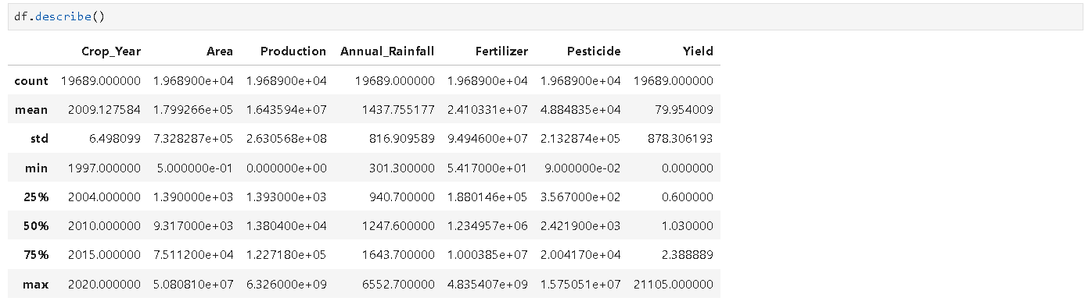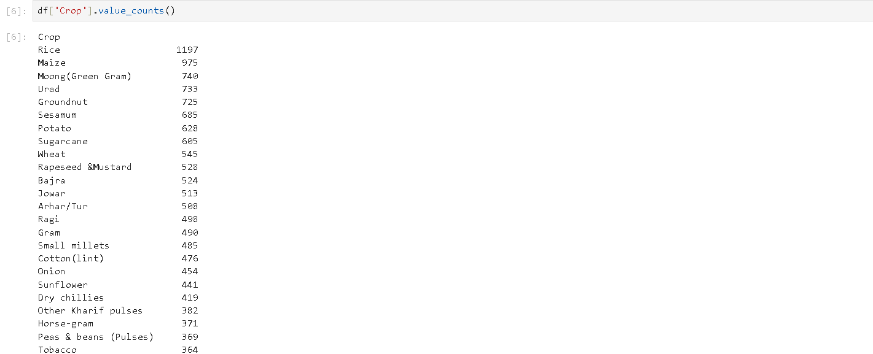

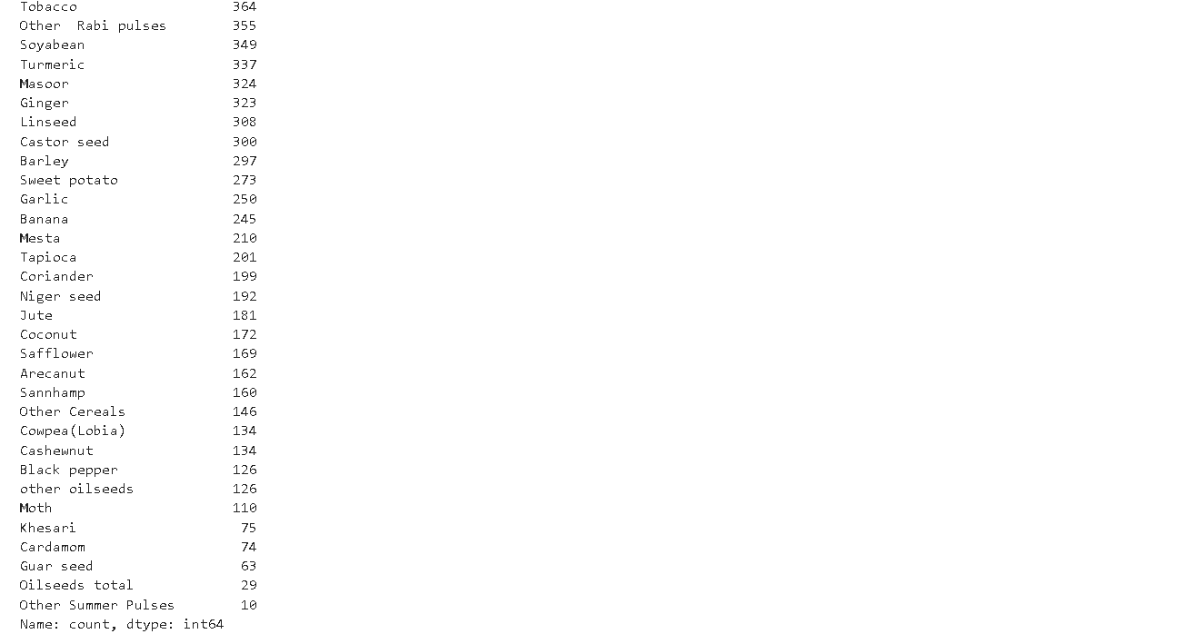

**1.3 Data Preprocessing**

Data preprocessing is a critical step before feeding data into machine learning models. This step involves cleaning, transforming, and preparing the dataset to ensure better performance of the models. For this project, the following preprocessing steps were performed:

* **Handling Missing Values**: Missing values in temperature, humidity, and soil moisture data were filled using statistical methods such as mean or median imputation.
* **Outlier Detection**: Used Boxplot to detect outliers and used IQR method to remove it.

Performing Data Preprocessing:

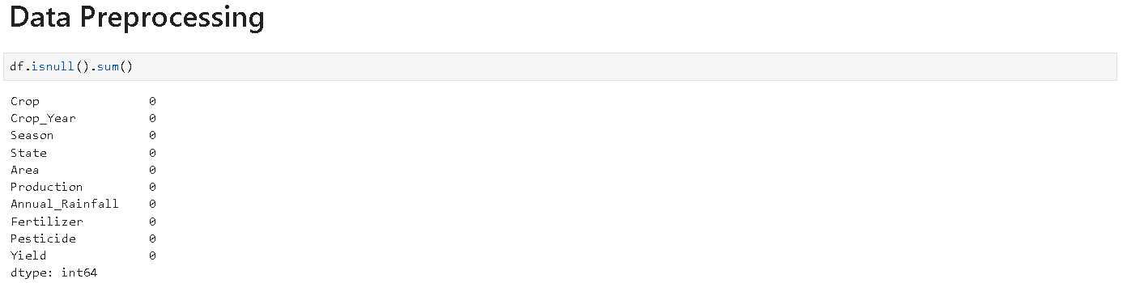



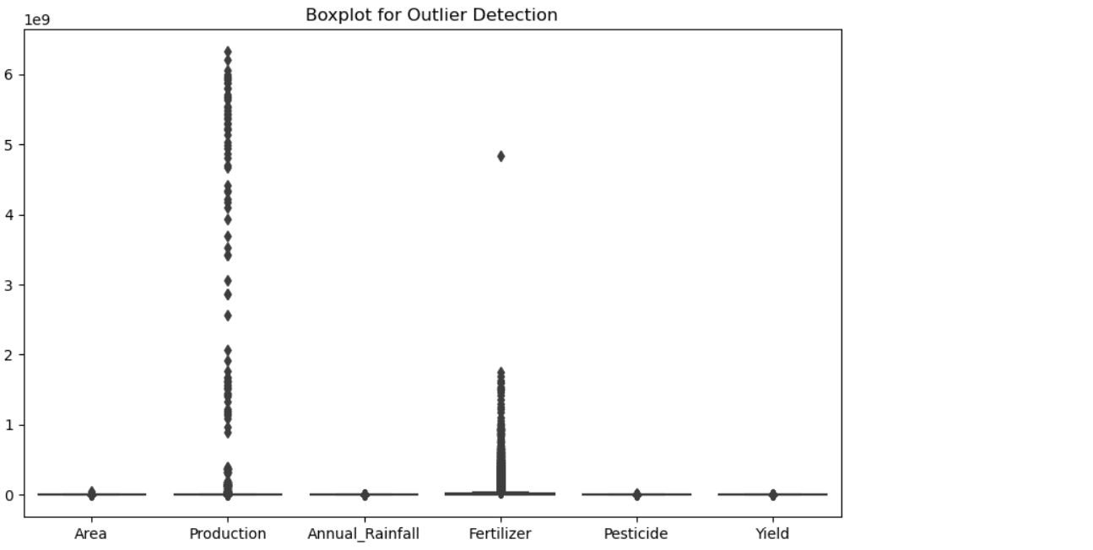

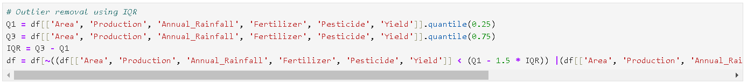



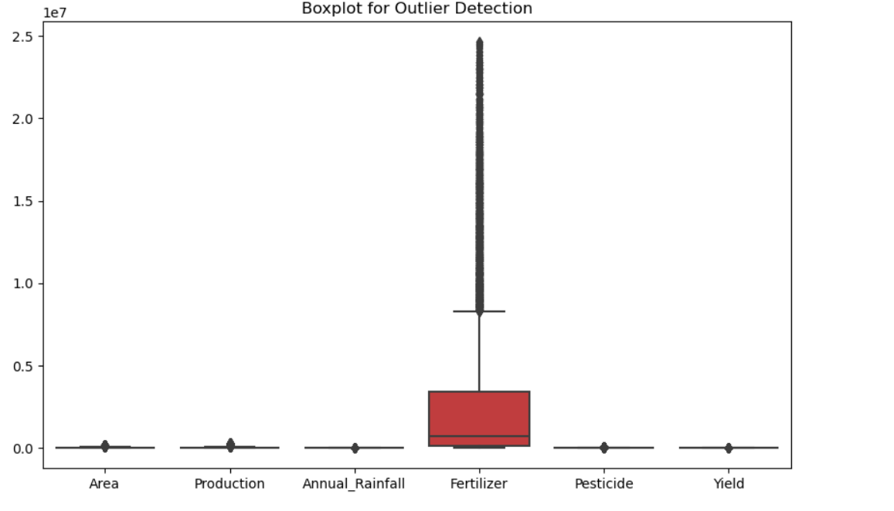

**1.4 Data Visualization**

Data visualization helps to visually interpret trends and patterns in the dataset, making it easier to draw insights for model building. In this project, several visualizations were generated to showcase the relationships between environmental factors and crop yield. Some key visualizations included:

* **Distribution Plots**: Distribution plots were used to analyze the spread of individual features like temperature, humidity, and soil moisture. These plots helped in identifying skewness, potential outliers, and the overall distribution of the data, which guided the decision on whether feature transformations were needed.
* **Scatter Plots**: Scatter plots were used to visualize the relationship between two features at a time, such as temperature vs. crop yield or humidity vs. pest occurrence. These plots allowed us to see if linear or nonlinear relationships exist between variables, providing insight into the nature of dependencies in the data.
* **Pair Plot**: A pair plot was generated to visualize relationships between all pairs of features. This multi-dimensional plot is a great way to observe pairwise correlations, patterns, and clustering tendencies in the data.
* **Correlation Heatmap**: A correlation heatmap was created to visually represent the correlations between all numerical features. This helped identify strongly correlated variables (positive or negative), which could influence the crop prediction model. Strong correlations might also lead to feature selection to avoid multicollinearity.

Performing Data Visualization:

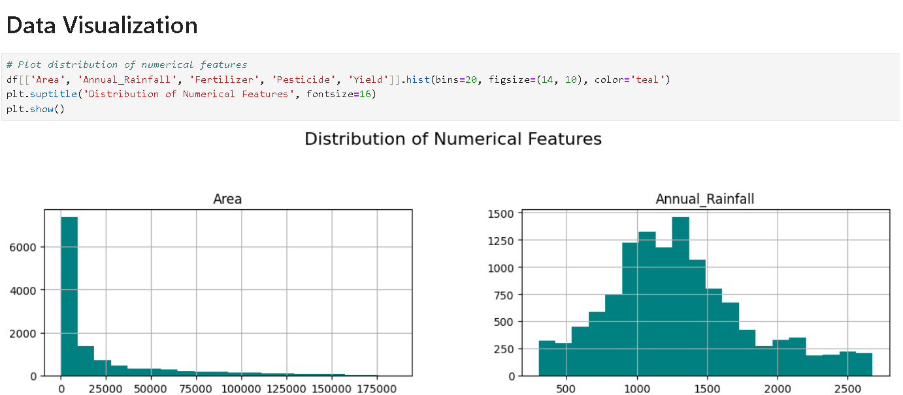

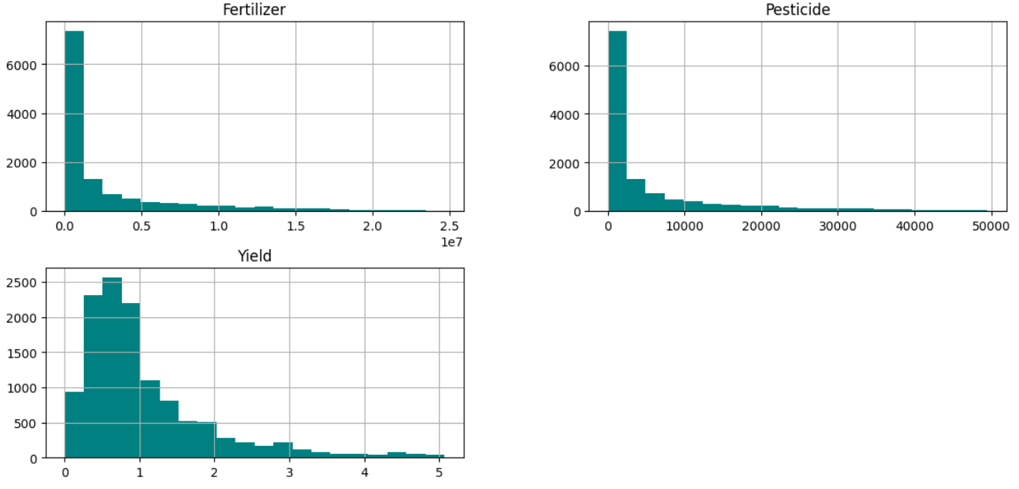



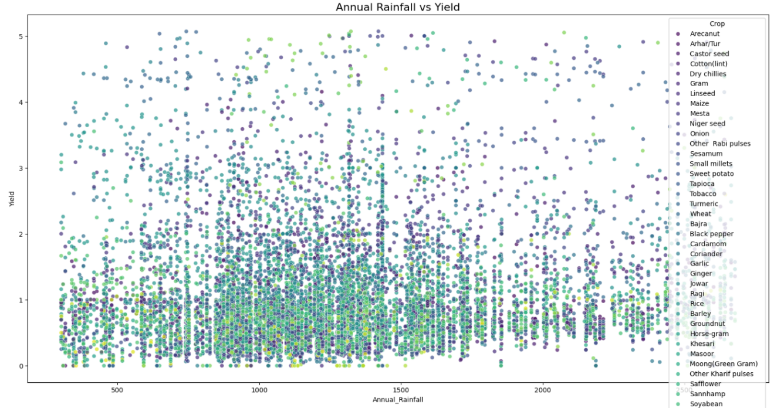

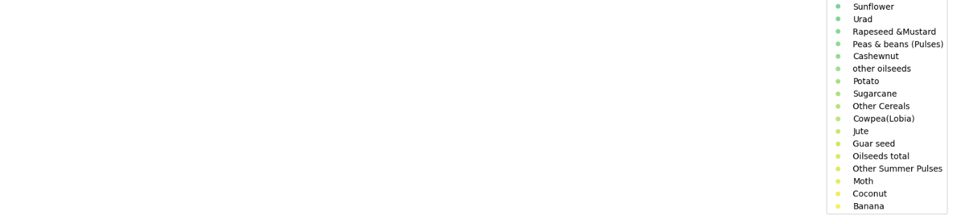



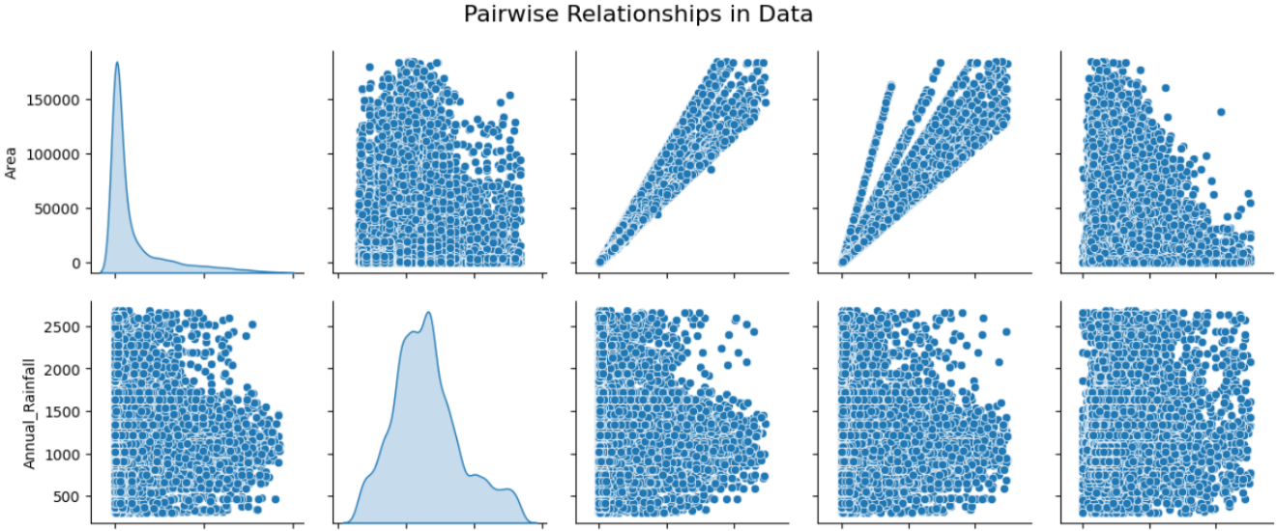

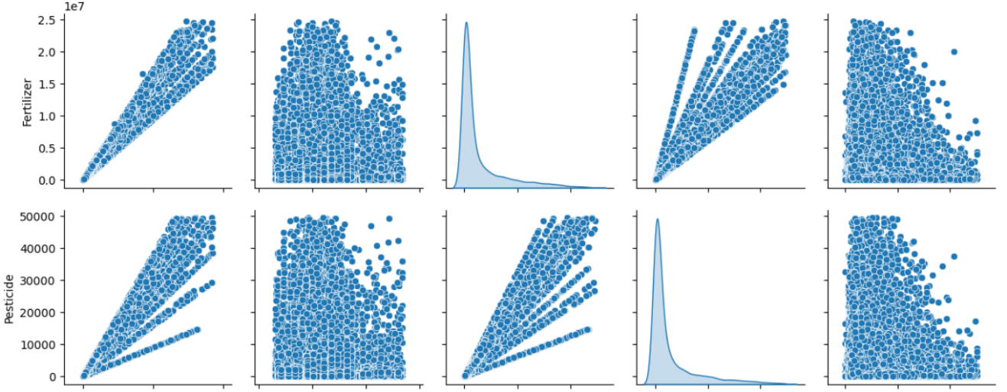

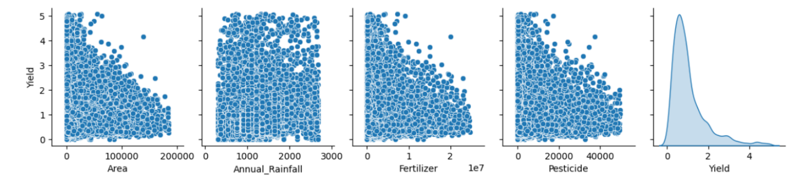

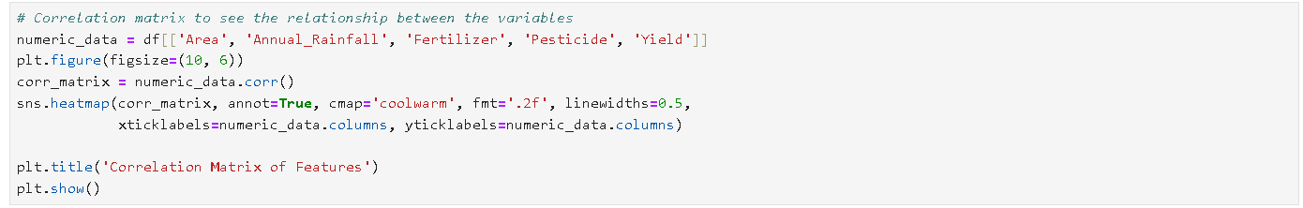

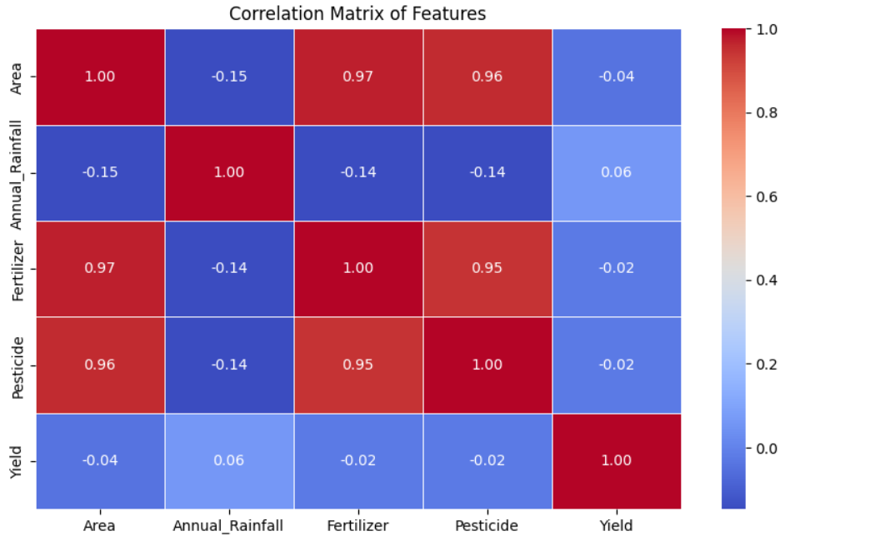

These visualizations offered a comprehensive view of the dataset, helping in better understanding the relationships and guiding the feature selection process for model building.

**1.5 Feature Scaling and Encoding**

Before feeding the data into the models, several preprocessing steps were carried out to ensure high-quality data for training and testing. This involved cleaning, feature scaling, and encoding categorical variables.

**1.5.1 Feature Scaling**  
Scaling is essential to ensure that features with different units (e.g., temperature in Celsius and rainfall in millimeters) do not disproportionately influence the model. For this project:

* **Standardization**: StandardScaler from the scikit-learn library, which ensures that features have a mean of 0 and a standard deviation of 1.

Performing Feature Scaling:

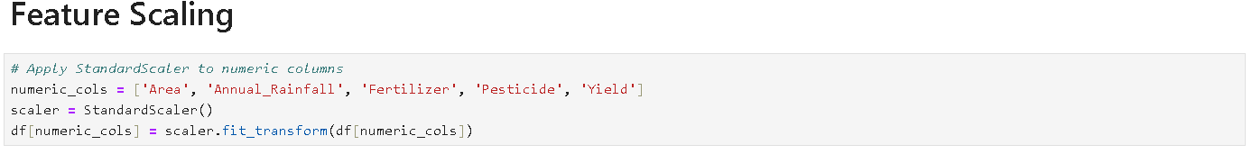

**1.5.2 Encoding**

Categorical features (such as pest types or crop categories) were encoded to convert them into a numeric format, which machine learning models can interpret.

* **One-Hot Encoding** was applied to nominal categories with no inherent order.

Performing One-Hot Encoding:

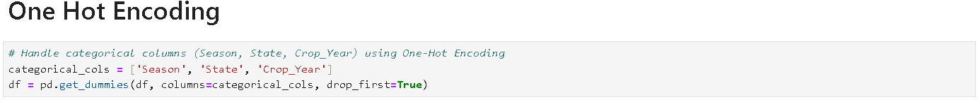

**1.6 Model Building and Evaluation**

In this section, two machine learning models: **Linear Regression** and **Random Forest Regressor**, were implemented to predict crop yield based on environmental features such as temperature, humidity, soil moisture, and rainfall.

**1.6.1 Linear Regression**  
Linear Regression is a simple model that fits a linear equation to the data. It was selected as the baseline model to understand how well a simple relationship between features and target variable (crop yield) could perform.

* **Implementation**: The model was implemented using the LinearRegression class from the scikit-learn library.
* **Performance**: The model was evaluated using Mean Squared Error (MSE), Root Mean Squared Error (RMSE), and R-squared score. It performed reasonably well, but showed limitations in capturing complex nonlinear relationships.

**1.6.2 Random Forest Regressor**  
Random Forest Regressor is an ensemble method that uses multiple decision trees to provide more accurate predictions by averaging the results of individual trees. It was chosen due to its ability to handle complex relationships and avoid overfitting.

* **Implementation**: The model was implemented using the RandomForestRegressor class from the scikit-learn library.
* **Performance**: Compared to Linear Regression, the Random Forest model provided better predictions, as indicated by lower RMSE and higher R-squared score. This model was chosen as the final candidate for deployment.

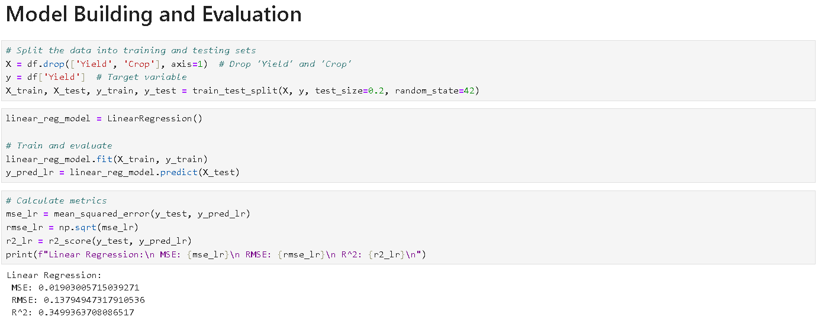

*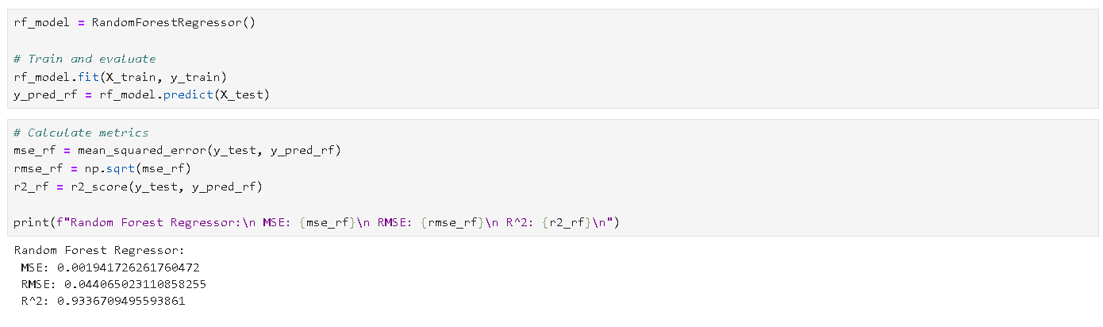***2. Conclusion**

The prototype development for crop prediction and pest/disease alerts demonstrates a functional machine learning-powered system. My contributions to the project include:

1. **Data Collection and Preprocessing**: Data was collected and preprocessed through cleaning, feature scaling, and encoding. Missing values were handled, and categorical variables were transformed into numerical representations to ensure model compatibility.
2. **Exploratory Data Analysis (EDA)**: EDA revealed important insights into the dataset, such as correlations between environmental factors and crop yields. Distribution plots, scatter plots, and correlation heatmaps highlighted critical trends and relationships.
3. **Data Visualization**: Data visualization techniques such as distribution plots, scatter plots, pair plots, and heatmaps provided clear insight into the data and helped identify key relationships between variables. This step also aided in validating assumptions and refining the feature set.
4. **Model Building and Evaluation**: Linear Regression and Random Forest Regressor, were built and evaluated using metrics like RMSE and R-squared. The Random Forest model performed significantly better than Linear Regression in predicting crop yields, making it the preferred model for deployment.

**3) Business Model Report for CropSense AI**

**1. Summary**

CropSense AI is a web-based platform designed to help small-scale farmers optimize crop management using predictive analytics. By integrating historical agricultural data, real-time weather forecasts, and soil conditions, CropSense AI provides actionable insights that improve productivity and profitability. This report outlines key aspects of CropSense AI’s business model, including revenue streams, customer segments, marketing strategies, and opportunities for future growth.

**2. Business Model Overview**

**A. Key Partners**

* **Agricultural Cooperatives**: Collaborate to extend outreach and provide user support.
* **Technology Providers**: Partner with IoT and data analytics companies to enhance platform capabilities.
* **Research Institutions**: Engage with universities for solution innovation and validation.

**B. Key Activities**

* **Data Collection**: Gather data from IoT sensors, weather stations, and satellite imagery.
* **Predictive Model Development**: Build and improve machine learning models for crop management.
* **User Support & Training**: Offer training and ongoing support for optimal platform use.

**C. Key Resources**

* **Data Scientists**: Develop and maintain predictive models.
* **UI/UX Designers**: Create an intuitive, user-friendly interface.
* **Software Developers**: Build and maintain the platform’s technical infrastructure.

**D. Value Proposition**

* **Affordable Insights**: Deliver cost-effective, actionable insights tailored to small-scale farmers.
* **Ease of Use**: Provide an intuitive interface requiring minimal technical expertise.
* **Real-Time Alerts**: Offer timely notifications on pest threats, weather changes, and planting recommendations.

**E. Customer Segments**

* **Small to Medium-Sized Farms**: Serve farmers with limited technical resources and operational scale.
* **Agricultural Cooperatives**: Work with cooperatives supporting small-scale farmers to expand platform adoption.

**F. Customer Relationships**

* **Community Engagement**: Build an online community through forums, webinars, and feedback mechanisms.
* **Customer Support**: Provide tutorials, FAQs, and personalized assistance for a seamless user experience.

**G. Distribution Channels**

* **Web-Based Platform**: Accessible via computers and smartphones for on-the-go access.
* **Digital Marketing**: Use social media, email campaigns, and online ads to attract users.

**H. Revenue Streams**

* **Subscription Model**:
  + *Monthly Subscription*: Recurring revenue from flexible monthly access.
  + *Annual Subscription*: Discounted pricing for users committing to a yearly plan.
* **Tiered Pricing**:
  + *Basic Tier*: Entry-level access for small farms.
  + *Standard Tier*: Suitable for medium-sized farms.
  + *Premium Tier*: Comprehensive features, including advanced analytics for larger farms.
* **Freemium Model**:
  + *Free Plan*: Basic access to attract users.
  + *Premium Features*: Charge for advanced tools and insights to encourage upgrades.

**3. Monetization Strategy**

**A. Subscription-Based Revenue**

* **Rationale**: A predictable, recurring revenue stream that fosters user retention, with monthly and annual options catering to different preferences and budgets.

**B. Tiered Pricing**

* **Rationale**: Scalable pricing allows CropSense AI to serve a wide range of farm sizes, maximizing revenue potential.

**C. Freemium Model**

* **Rationale**: Offering a basic free version lowers entry barriers and attracts users, while the paid tier capitalizes on increased user engagement for advanced functionalities.

**D. Data Monetization**

* **Rationale**: Aggregate anonymized data to provide insights to agricultural stakeholders (e.g., suppliers, policymakers), creating additional revenue streams while maintaining user privacy.

**E. Partnership & Affiliate Programs**

* **Rationale**: Form strategic partnerships with agricultural organizations to expand platform reach and generate revenue through affiliate deals and partnership programs.

**4. Marketing Strategy**

**A. Targeted Digital Marketing**

* **Approach**: Utilize Google Ads, social media campaigns, and agricultural forums to target small farmers and cooperatives.
* **Objective**: Build brand awareness and drive traffic to the platform.

**B. Content Marketing**

* **Approach**: Create educational blog posts, webinars, and videos addressing common farming challenges and showcasing platform value.
* **Objective**: Position CropSense AI as a leader in agri-tech and generate organic leads.

**C. Case Studies & Testimonials**

* **Approach**: Feature success stories and testimonials from pilot programs and satisfied users.
* **Objective**: Build credibility and trust with potential customers.

**D. Partnerships with Agricultural Organizations**

* **Approach**: Collaborate with cooperatives, extension services, and NGOs to promote the platform and provide in-depth training.
* **Objective**: Leverage existing networks to expand user adoption.

**E. Community Engagement**

* **Approach**: Foster an online community through forums and feedback systems to encourage interaction and user loyalty.
* **Objective**: Create a strong user base that actively promotes the platform.

**5. Future Growth Opportunities**

**A. Expansion of Platform Features**

* **Advanced Analytics**: Integrate sophisticated predictive analytics, such as climate impact models and long-term yield forecasts.
* **IoT Device Integration**: Expand compatibility with a broader range of IoT sensors for comprehensive soil and crop monitoring.

**B. Geographic Expansion**

* **Target New Markets**: Expand into emerging agricultural markets in Asia, Africa, and Latin America, adapting the platform to local needs.
* **Localization**: Customize the platform for different languages, agricultural practices, and regulatory environments.

**C. Strategic Partnerships**

* **Agri-Tech Collaborations**: Partner with other tech providers to bundle complementary services like drone monitoring and soil testing.
* **Research Collaborations**: Work with academic institutions to continue innovating and validating the platform’s effectiveness.

**D. Educational Initiatives**

* **Farmer Training Programs**: Develop training modules to help farmers understand data-driven farming and the platform’s functionalities.
* **Certification Programs**: Offer certifications for farmers who complete training, enhancing their credentials.

**E. Sustainability and Carbon Credits**

* **Sustainable Practices**: Incorporate features that encourage resource-efficient and sustainable farming practices.
* **Carbon Credit Opportunities**: Explore partnerships with environmental organizations to help farmers earn carbon credits through sustainable farming practices tracked by the platform.

**F. Data Monetization**

* **Market Insights**: Aggregate anonymized data to generate market insights for stakeholders such as suppliers, cooperatives, and policymakers.
* **Custom Analytics**: Offer tailored reports and analytics to larger agricultural enterprises and government agencies.

**G. Mobile Application Development**

* **Mobile Access**: Develop a mobile application to provide real-time insights, alerts, and recommendations, improving user engagement and accessibility.

**H. Community Building**

* **User Forums**: Establish online user communities where farmers can share experiences and collaborate.
* **Continuous Feedback**: Implement ongoing feedback mechanisms to adapt the platform based on user needs and evolving agricultural trends.

**4) Financial Equation**

**– Revenue from Subscription for Crop Management Services**

**1. Basic Idea**

The financial model for subscription-based crop management services can be represented using a simple equation:

* **Revenue** = **Number of Farms** × **Subscription Fee Per Farm**

**Example:**

* **Number of Farms**: 200 small farms
* **Subscription Fee**: $50 per month

The revenue is calculated as:

Revenue=200×50=10,000Revenue = 200 \times 50 = 10,000Revenue=200×50=10,000

Thus, the monthly revenue would be **$10,000**.

**2. Advanced Financial Equation with Churn Rate**

To account for subscription cancellations (churn), we modify the equation:

* **Revenue** = (**Number of New Farms** - **Churned Farms**) × **Subscription Fee Per Farm**

Where:

* **Churned Farms**: Farms that cancel their subscription during the month.
* **New Farms**: Farms that sign up for the service during that period.

**Example with Churn Rate:**

* **Initial Farms**: 200
* **Churn Rate**: 5% of farms churn each month
* **New Farms**: 20 new farms per month
* **Subscription Fee**: $50 per month

First, calculate the churned farms:

ChurnedFarms=200×0.05=10Churned Farms = 200 \times 0.05 = 10ChurnedFarms=200×0.05=10

Now, apply the formula:

Revenue=(200+20−10)×50=210×50=10,500Revenue = (200 + 20 - 10) \times 50 = 210 \times 50 = 10,500Revenue=(200+20−10)×50=210×50=10,500

Thus, the monthly revenue after accounting for churn and new sign-ups would be **$10,500**.

**3. Additional Factors to Consider in Crop Management Services:**

**A. Multiple Subscription Tiers:**

Different plans may be offered based on the size of the farm or features included.

Revenue=(Number of Farms on Basic Plan×Basic Fee)+(Number of Farms on Premium Plan×Premium Fee)Revenue = (Number\ of\ Farms\ on\ Basic\ Plan \times Basic\ Fee) + (Number\ of\ Farms\ on\ Premium\ Plan \times Premium\ Fee)Revenue=(Number of Farms on Basic Plan×Basic Fee)+(Number of Farms on Premium Plan×Premium Fee)

**B. Seasonal Impact:**

The farming season could affect subscription levels, with higher demand during planting or harvest periods.

**C. Farm Growth:**

As small farms grow, they may upgrade to higher-priced tiers, impacting revenue positively.

**D. Lifetime Value (LTV) of a Farm:**

LTV helps estimate the long-term revenue from each farm.

LTV=Average Subscription Length (in months)×Monthly FeeLTV = Average\ Subscription\ Length\ (in\ months) \times Monthly\ FeeLTV=Average Subscription Length (in months)×Monthly Fee

For example:

* **LTV** = 24 months × $50 = $1,200

This means each farm would bring in an average of **$1,200** in total revenue over two years.

**4. Final Revenue Model**

**A. Tiered Pricing Model:**

The platform may offer multiple tiers based on farm size and feature requirements:

* **Basic Tier**: Entry-level access to essential features like weather forecasts and basic soil monitoring.

RevenueBasic=Number of Basic Farms×Basic Subscription FeeRevenue_{\text{Basic}} = Number\ of\ Basic\ Farms \times Basic\ Subscription\ FeeRevenueBasic​=Number of Basic Farms×Basic Subscription Fee

* **Standard Tier**: Expanded features such as pest control advice and irrigation management for medium-sized farms.

RevenueStandard=Number of Standard Farms×Standard Subscription FeeRevenue_{\text{Standard}} = Number\ of\ Standard\ Farms \times Standard\ Subscription\ FeeRevenueStandard​=Number of Standard Farms×Standard Subscription Fee

* **Premium Tier**: Comprehensive access, including advanced analytics, predictive tools, and crop yield forecasts for large farms.

RevenuePremium=Number of Premium Farms×Premium Subscription FeeRevenue_{\text{Premium}} = Number\ of\ Premium\ Farms \times Premium\ Subscription\ FeeRevenuePremium​=Number of Premium Farms×Premium Subscription Fee

**B. Freemium Model:**

* **Free Plan**: Attracts smaller farms or new users with basic features.

RevenueFree=0Revenue_{\text{Free}} = 0RevenueFree​=0

* **Premium Features**: Farms can upgrade to paid tiers for advanced insights, encouraging transitions from free to paid plans.

RevenueFreemium=Free Plan Farms Upgraded×Subscription Fee of Chosen TierRevenue_{\text{Freemium}} = Free\ Plan\ Farms\ Upgraded \times Subscription\ Fee\ of\ Chosen\ TierRevenueFreemium​=Free Plan Farms Upgraded×Subscription Fee of Chosen Tier

**5. Total Revenue**

Combining both the tiered pricing and freemium model, the total revenue can be calculated as:

Total Revenue=RevenueBasic+RevenueStandard+RevenuePremium+RevenueFreemium UpgradedTotal\ Revenue = Revenue_{\text{Basic}} + Revenue_{\text{Standard}} + Revenue_{\text{Premium}} + Revenue_{\text{Freemium\ Upgraded}}Total Revenue=RevenueBasic​+RevenueStandard​+RevenuePremium​+RevenueFreemium Upgraded​

**Example Breakdown:**

* **Basic Tier**: 100 farms subscribing at $30/month
* **Standard Tier**: 50 farms subscribing at $50/month
* **Premium Tier**: 20 farms subscribing at $100/month
* **Freemium Upgrades**: 10 free users upgrading to the standard tier at $50/month

Total Revenue=(100×30)+(50×50)+(20×100)+(10×50)=3,000+2,500+2,000+500=8,000 USD/monthTotal\ Revenue = (100 \times 30) + (50 \times 50) + (20 \times 100) + (10 \times 50) = 3,000 + 2,500 + 2,000 + 500 = 8,000\ USD/monthTotal Revenue=(100×30)+(50×50)+(20×100)+(10×50)=3,000+2,500+2,000+500=8,000 USD/month

**6. Conclusions**

The financial model for CropSense AI demonstrates a scalable and flexible revenue generation approach that effectively caters to small, medium, and large-scale farms. By adopting a **subscription-based model** with tiered pricing, CropSense AI can serve a wide range of users, ensuring that the platform remains accessible while still offering advanced features for more sophisticated operations.

Key factors such as **churn rate**, **farm growth**, and the **lifetime value (LTV)** of each customer play a critical role in predicting long-term revenue sustainability. Additionally, the **freemium model** lowers the barrier for entry, providing a path for new users to transition to paid tiers, which increases overall engagement and retention.

In conclusion, by continuously refining its **predictive analytics** capabilities, engaging in **strategic partnerships**, and expanding into **emerging markets**, CropSense AI is well-positioned to grow its user base, increase profitability, and contribute significantly to the agricultural sector. Moreover, the potential for **data monetization** and integration of **IoT devices** opens up new avenues for revenue generation, creating future opportunities for innovation and growth.

CropSense AI’s business model is not only built to be profitable but also to promote sustainability in agriculture, empowering farmers to make data-driven decisions that enhance productivity and reduce risks